Exercise Session 1 (RDF)

# Exercise 1: RDF Triples

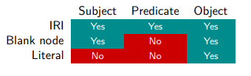

| **SUBJECT** | **PREDICATE** | **OBJECT** |
| --- | --- | --- |
| ex:Bob | rdf:type | foaf:Person |
| ex:Bob | foaf:firstName | “Robert”^^xsd:string |
| ex:Bob | foaf:lastName | “Taylor”^^xsd:string |
| ex:Bob | foaf:knows | ex:Alice |
| ex:Alice | foaf:name | “Alice Gorlami”^^xsd:string |
| ex:Alice | foaf:age | “55”^^xsd:integer |
| ex:Alice | dbo:birthPlace | “Milano”@it |
| ex:Alice | ex:heightInCm | “176.5”^^xsd:decimal |
| _:MarkIlBurlone | rdf:type | foaf:Person |
| ex:Alice | foaf:knows | _:MarkIlBurlone |
| _:MarkIlBurlone | foaf:knows | ex:Bob |

# ExBlank Nodes and RDF Graphs

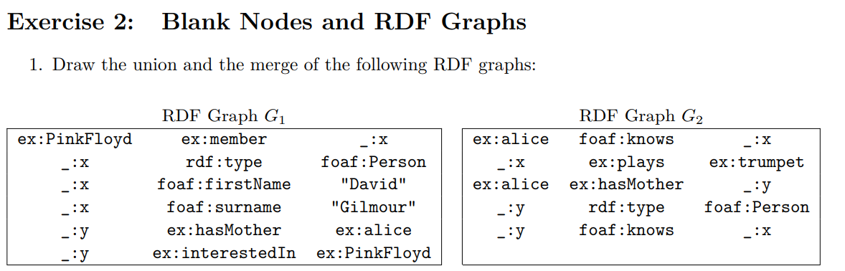

### Union and Merge of two graphs

* **Union**: make the union of the two graphs, if we have blank nodes of different graphs with the same name, then they represent the same individual. Treat the blank nodes like constants.
* **Merge**: before doing the union of the two graphs, rename the blank nodes, in such a way that the two graphs do not share the same name for their blank nodes.

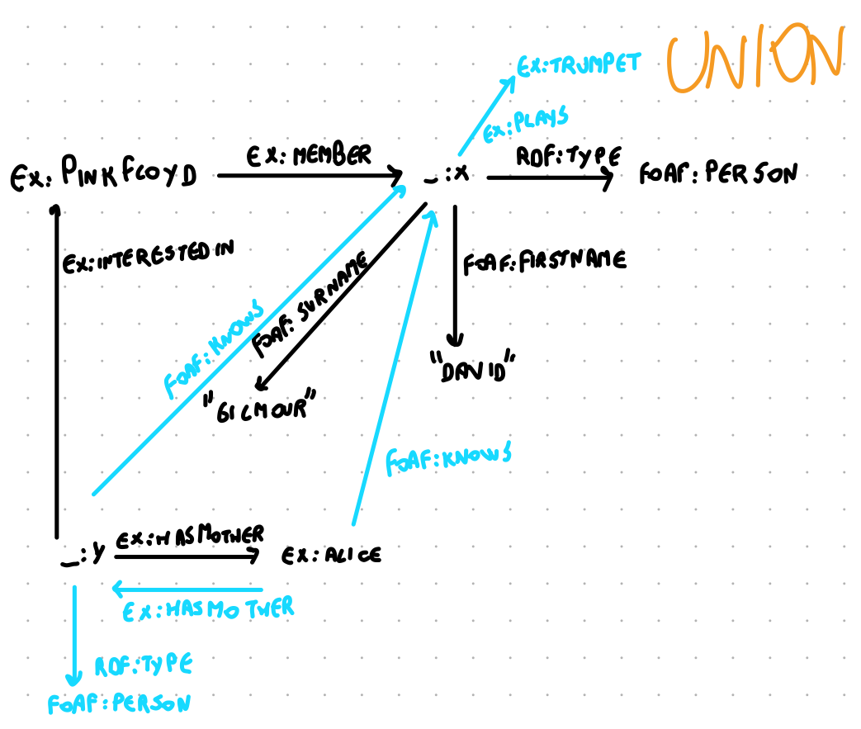

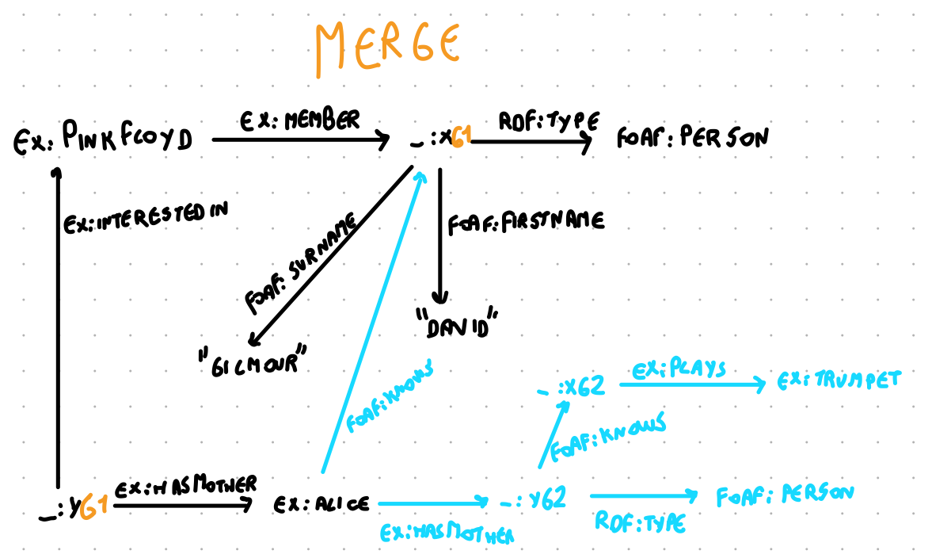

# Exercise 3: Simple Interpretations and Entailment

Write down a simple interpretation that satisfies the union of the RDF graphs G1 and G2 from Exercise 2.

# Exercise 4: Turtle

Write down the merge of G1 and G2 from Exercise 2 as a Turtle document.

| . (dot) | to end a sentence |
| --- | --- |
| ; (semicolon) | to refer to the last subject |
| , (comma) | to refer to the last subject and last predicate |
| + (after the predicate) | Transitive closure, for “*ex:alice ex:hasParent****+*** *?x”* you represent all the ancestors of Alice |
| * (after the predicate) | Transitive closure, for “*ex:alice ex:hasParent****\**** *?x”* you represent all the ancestors of Alice but also including Alice |
| / (between two predicates) | *“ex:bob foaf:knows****/****foaf:name****?*** *?y”* . Is for People known by Bob, or the names of people known by Bob |
| SELECT * | Will select all the variables that are in the WHERE |

@prefix ex: <http://example.org/> .

@prefix foaf: <http://xmlns.com/foaf/0.1/>.

ex:PinkFloyd ex:member _:xg1.

_:xg1 a foaf:person;

foaf:firstname “David” ;

foaf:surname “Gilmour”;

_:yg1 ex:hasMother ex:alice;

ex:interestedIn ex:PinkFloyd.

ex:alice foaf:knows _:xg1;

ex:hasMother _:yg2.

_:yg2 a foaf:person;

foaf:knows _:xg2.

_:xg2 ex:plays ex:trumped.

# Exercise 5: Reification

Exercise Session 2